With valued input from parents and pupils, we have updated our PE kit. Some key considerations were cost, value for money and choice. Much of the kit is available from a variety of retailers. We chose Halbro as our preferred supplier of our bespoke items. They do supply all the clothing products required for PE at QEGS Penrith.

Halbro was established in 1919 and has an excellent reputation for personal service, quality assurance and aftercare. Their products are worn by several local sports clubs and secondary schools, as well as many other sporting organisations nationally.

PE & Games Kit (New for Year 7 2021)
Compulsory  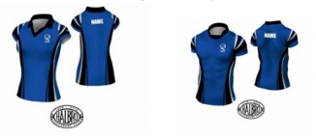 |  |  |  |  | 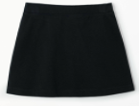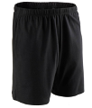
Blue Games / PE Top (Only available from Halbro).  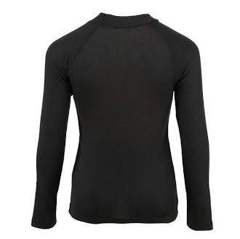  Any all black long-sleeved skin.  White sports socks /ankle socks (Indoor use).  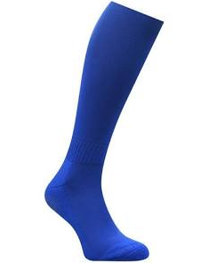  Royal blue ‘football’ socks. |  |  |  |  | Any all black skort or short.  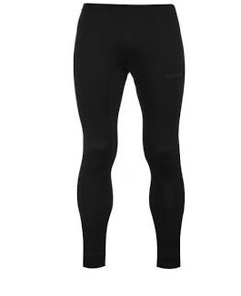  Any all black leggings / Skins.  Trainers – non marking soles  Football or Rugby boots.  (Loan pairs may be available from school)
Shin guards for Football and Hockey.
Mouth guard for rugby & hockey - highly recommended
(A dentist (Opro) may visit school in September if there is sufficient interest in professionally fitted mouth guards.)
Optional Extras |  | From September 2021 any PE over top needs to be from Halbro or the old school kit. https://halbro.com/product-category/your-store/qegs-penrith/
Evo Over top Midlayer- suitable as outer garment for indoor and outdoor sports with no contact.  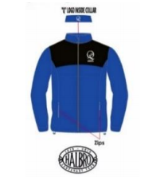 |  |  | Hoodie- suitable as outer garment for indoor and outdoor sports with no contact.  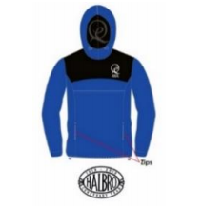 |  |  | Evo training top- suitable for contact sports (no zips/hoods).  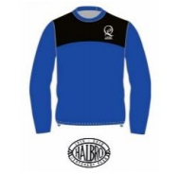
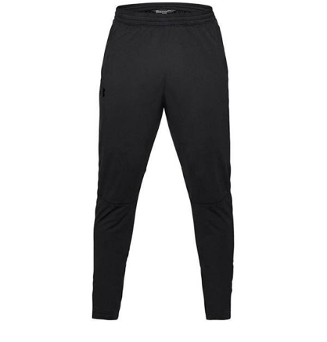  All black track suit bottoms. |  |  | Optional indoor royal blue polo shirt  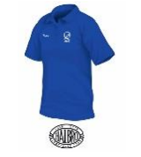 |  |  | Athletics top for athletes/runners.  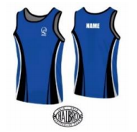
 | Students may continue to wear the current school PE kit until it needs to be replaced.

